Kids’ Couscous Salad
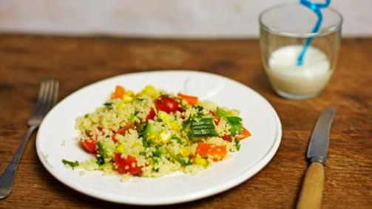
Ingredients
- ¼ cucumber
- 10 cherry tomatoes or 3 larger tomatoes
- 1 pepper, any colour
- 2 spring onions
- 100g sweetcorn, frozen or tinned (drained weight)
- 150g couscous
- small lemon, juice only (you can also use orange)
- 1 tbsp olive oil
- 200ml boiling water
Extras you could try adding:
- small bunch herbs, such as parsley and coriander
- small handful olives, chopped
- small handful dried fruits such as raisins, sultanas, chopped dried apricots
What to do
- Put the couscous into a large bowl, cover with the boiling water and leave for 10 minutes.
- Fluff up the couscous with a fork and add the lemon juice and oil.
- Add the cucumber, tomatoes, pepper, onion and sweetcorn then mix it all together.
- Enjoy your healthy food!

