Flapjacks
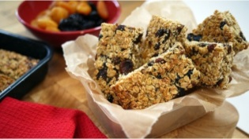
Ingredients
- 50g prunes (chopped), dried
- 50g apricots (chopped), dried
- 50g raisins
- 175g porridge oats
- 50g butter
- 3 tbsp honey
- 1 egg, beaten
You will need:
Baking tin approx 9 x 7 inch/22 x 18cm
What to do
1. Preheat the oven to gas mark 4/180'C/Fan oven 170'C.
2. Lightly grease the baking tin.
3. Chop the prunes and apricots into small pieces - put the prunes, apricots, raisins or sultanas and oats into a mixing bowl and stir until evenly mixed.
4. In a small saucepan melt the butter with the honey and then add to the fruit and oats, and mix well.
5. Beat the egg and when the fruit and oat mixture has cooled slightly, add this to the mixture.
6. Put the mixture into the greased tin and level the surface with a spoon.
7. Bake for 15-20 minutes until a pale golden brown.
8. Leave in the tin until almost cold and then mark out squares with a sharp knife and loosen around the edges.
9. Remove from the tin to finish cooling.

